Machine Learning
Machine learning is the subfield of AI where models learn directly from data. Many different types of algorithms and models can be used for machine learning and in most cases, developers will test a whole selection to find the best one for their specific goal.

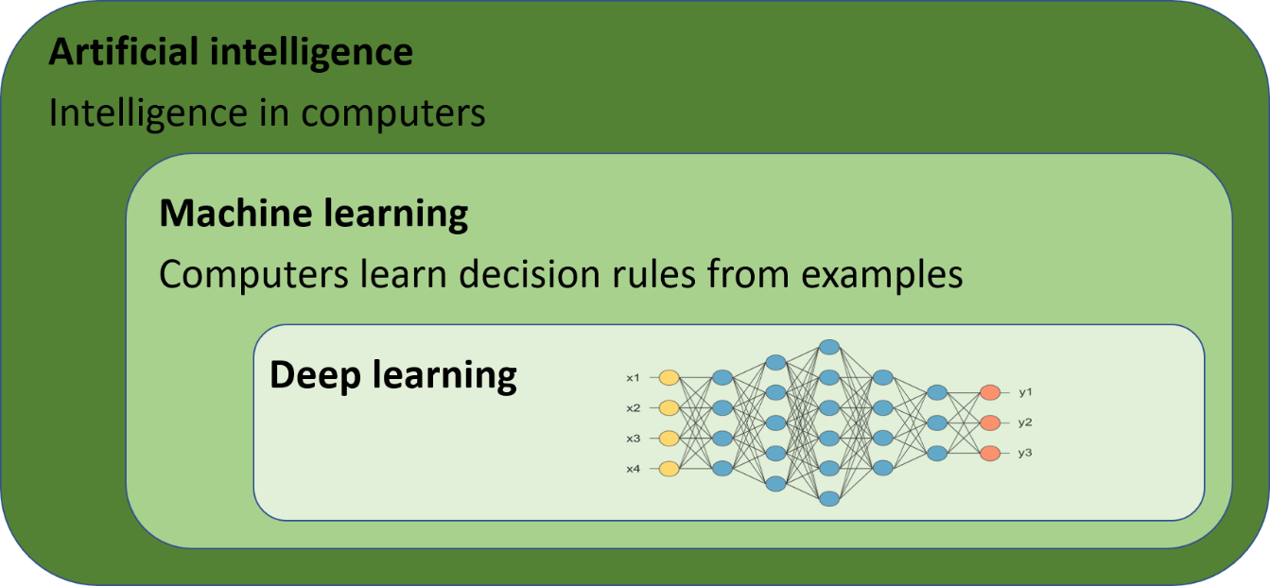

Machine learning includes both deep learning and non-deep learning approaches. Deep learning uses deep neural networks as models. Deep learning has evolved in an extraordinary way in recent years thanks to several important technological breakthroughs. It is the major driver behind the rapid AI transformation that is taking place and has applications in many areas of medicine and life science, ranging from powerful diagnostic tools to autonomous robots.

Machine learning that isn’t deep learning is often called “classical” or “traditional” machine learning. Confusingly, many people simply refer to classical machine learning as “machine learning” and contrast it with “deep learning” even though deep learning is also a form of machine learning. Classical machine learning may sound outdated but is still widely used today, especially for tabular data. It can for example be applied to classification tasks and to the prediction of numerical values, which is usually referred to as regression. For such use cases, classical machine learning can often perform just as well or even better than deep learning, while requiring a fraction of the computational resources and providing better explainability.

