Deep Neural Networks
Deep learning is a subfield of machine learning that uses deep neural networks as models.
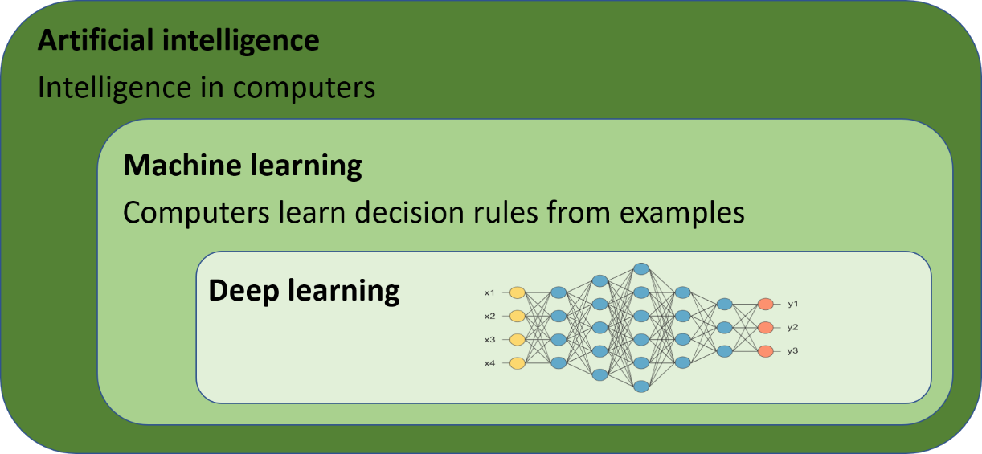
Deep learning has evolved rapidly in recent years as a result of several important technological breakthroughs. It is a major driver of the ongoing transformation in AI and has applications in many areas of medicine and life science, ranging from powerful diagnostic tools to autonomous robots. This section introduces the fundamental structure and function of deep neural networks.
A neural network can only process numerical data. Therefore, if necessary, the input data must first be converted into a suitable numerical representation.
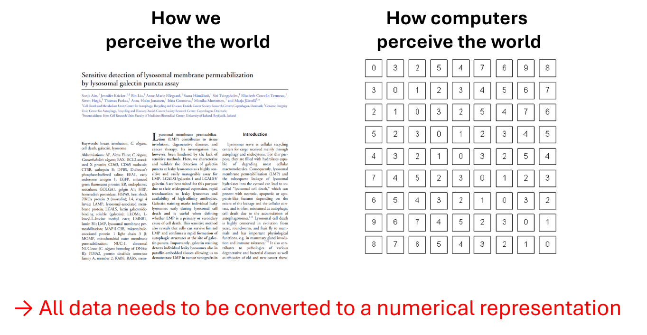
Deep neural networks were inspired by the structure of the human brain. Instead of real nerve cells, which are called neurons, deep neural networks are made up of artificial neurons, often millions or even billions of them. These artificial neurons, which are also called nodes, are not physical components. They consist of small sets of mathematical calculations that are carried out by a computer.
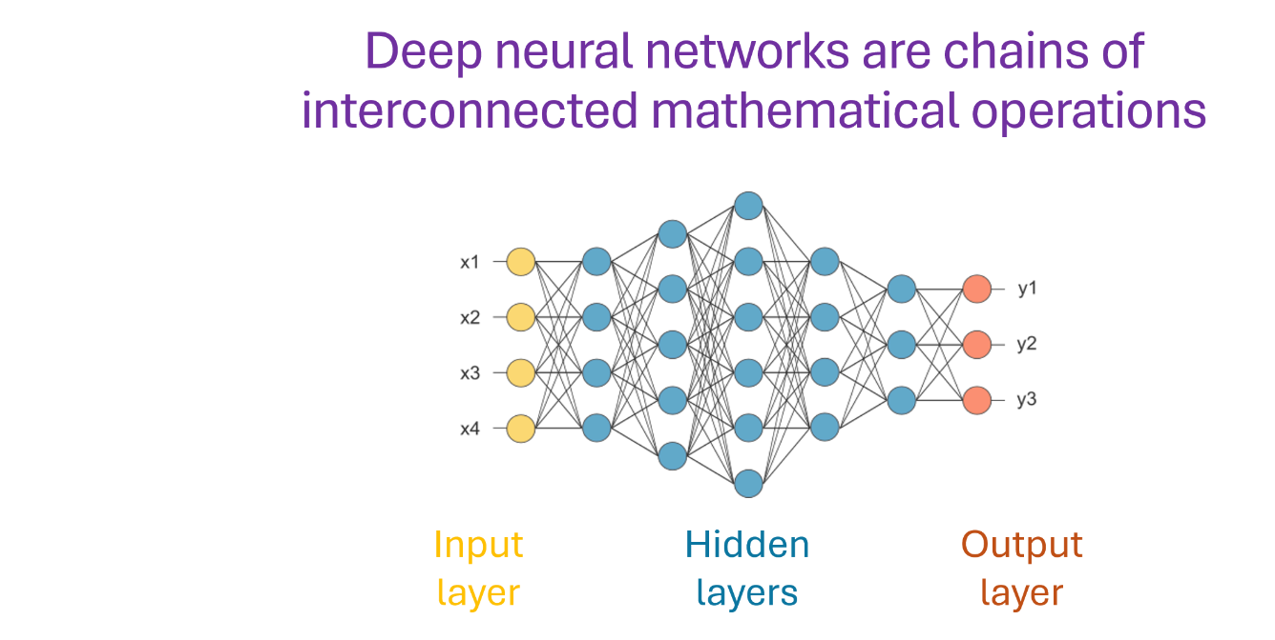
To form a neural network, artificial neurons are connected to each other and arranged in layers. The first layer is called the input layer. This layer receives the input data—first the training data and later the unknown data on which the model's task is to be performed.
The last layer is called the output layer. It produces the output of the model, such as a prediction or an image. As with the input, the output is numerical and may therefore require subsequent conversion into a more interpretable form.
Between the input and output layers are the hidden layers, where most of the calculations take place. Deep neural networks contain many hidden layers, usually tens to hundreds. The presence of multiple hidden layers is the origin of the term deep in deep neural network and deep learning.
The individual artificial neurons within these layers perform the basic calculations of the network. Like biological neurons, artificial neurons receive inputs, combine and process them, and produce an output. In an artificial neuron, this processing consists of a series of mathematical calculations.
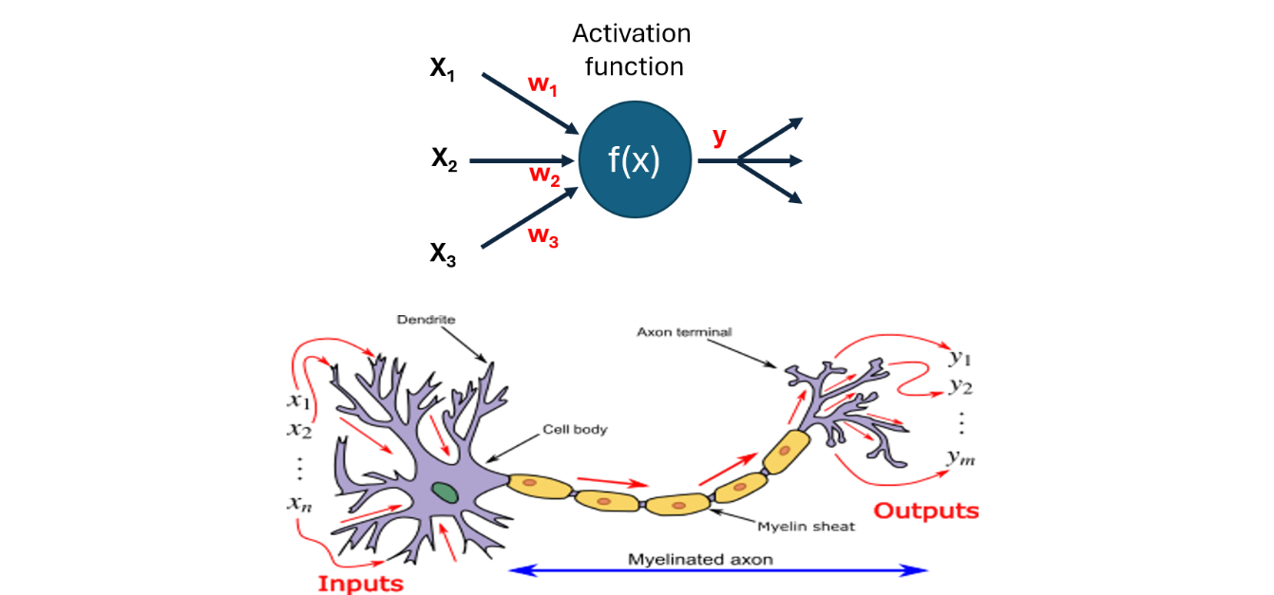
Consider a simple artificial neuron that receives three numbers as inputs, denoted x1, x2, and x3. In the input layer, these values could, for example, correspond to three different measurements from a patient's blood sample. In subsequent network layers, the inputs instead typically consist of outputs produced by connected nodes in the preceding layers.
Each input arriving at a neuron is multiplied by a weight, which reflects the relative importance of that input. The corresponding weights can be denoted w1, w2, and w3. The weighted inputs are then summed together with a bias, denoted b, which increases the flexibility of the calculation. The resulting value, denoted z, can be written as:
z = w1x1 + w2x2 + w3x3 + b
The value z is subsequently passed to another calculation defined by an activation function. This is typically a simple nonlinear function, such as the ReLU or sigmoid function. Applying the activation function produces the output of the neuron.
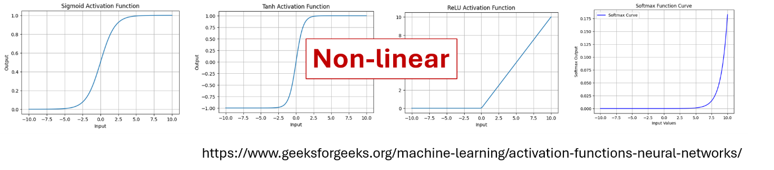
Calculations proceed stepwise through the network. Outputs from neurons in one layer are used as inputs to neurons in subsequent layers until the output layer is reached. However, neural networks do not always follow a simple sequential structure. Connections can skip layers or loop back to previous layers. Networks can also contain specialized layers that aggregate or transform information in other ways as it passes through the network.
The exact configuration of nodes, layers, connections, and calculations determines how input data is combined and transformed. This configuration is called the network architecture and can be regarded as the blueprint for constructing a neural network model. Many different architectures have been developed for different tasks and data types. Some major architecture types include the following:
Convolutional neural networks (CNNs) are widely used to identify patterns in images, such as X-rays or satellite images, as well as in other two- or three-dimensional data.
Recurrent neural networks (RNNs) and Long Short-Term Memory networks (LSTMs) are characterized by feedback mechanisms that make them suitable for sequential data, such as time series of experimental measurements.
Transformers were originally developed for text and are used, for example, in document classification, information extraction, and generative AI chatbots. Transformer variants have subsequently been developed for other data types, including images. Transformers have also largely replaced RNNs and LSTMs in many applications involving sequential data.
Other widely used types of generative models include Generative Adversarial Networks (GANs), Variational Autoencoders (VAEs), and diffusion models. These approaches can be used to generate realistic artificial data, for example for training purposes or data augmentation.
Graph neural networks (GNNs) are designed for data represented as graphs, such as cellular signaling networks or chemical structures.
These represent only some of the more common types of neural networks, and new architectures continue to be developed.
It is generally not possible to determine in advance which architecture will perform best for a particular task. Comparing different architectures is therefore an important component of many AI projects. Developers may also combine multiple models or construct hybrid architectures, for example when several types of input data need to be processed. Even when a single data type is used, an ensemble of separately trained models can be beneficial and may improve overall performance.

Summary
Deep neural networks primarily consist of layers of interconnected artificial neurons—virtual units in which mathematical calculations are performed. Information is processed stepwise through the network, beginning at the input layer, passing through the hidden layers, and eventually reaching the output layer, which produces the final network output.
The specific arrangement of neurons, connections, and calculations is referred to as the network architecture. Selecting an appropriate architecture is an important part of developing an AI model and commonly requires comparison and experimentation.

